BCH AJAX Plug-In Users’ Guide

Published 15th february 2008

This manual version is based on the actual deployed version of BCH Ajax Plug-in, as of the date of publication. All minor updates and changes will be published in the corresponding UNEP-GEF Biosafety Unit knowledge sharing site, http://moodle.unep.ch, under the course DEVELOPING national BCH applications with AJAX, using the available discussions and news forums.
Major updates and changes will be collected and included in new versions or editions.

CONTENTS

List of Figures 3
List of Tables 3
List of Acronyms and Abbreviations 4
List of Acronyms and Abbreviations 4
Introduction to the Module 5
Section 1. The BCH AJAX Plug-In 6
1.1 Overview of BCH AJAX Plug-in 6
1.2 Compatibility 6
1.3 Maintenance 6
1.4 Integration 7
1.5 Customization 8
1.5.1 Document Type 8
1.5.2 Country 9
1.5.3 Language 17
Section 2. Embedding the JavaScript and AJAX Plug-In 19
2.1 Embedding the JavaScript 19
2.2 Integrating the AJAX Plug-In 20
Section 3. Application of AJAX Plug-In to the National BCH Webpage 23
3.1 Displaying Information on National Focal Point(s) 23
3.1.1 Opening the Bahamas Biosafety Clearing-House Webpage on Focal Point(s), focalpoint.htm 23
3.1.2 Inserting the JavaScript and AJAX Plug-in 24
3.1.3 Displaying the webpage using the browser 26
3.1.4 Information generated by the use of AJAX Plug-In 27
3.2 Some More Examples Using Other Web Development Tools 28
3.2.1 Using PHP Hypertext Preprocessor (PHP) 28
3.2.1.1 Opening the Egyptian Biosafety Clearing-House Webpage, regulations.php 28
3.2.1.2 Inserting the JavaScript and AJAX Plug-In 29
3.2.1.3 Displaying the webpage using the browser 31
3.2.2 Using Active Server Pages (ASP) 31
3.2.2.1 Opening the Egyptian Biosafety Clearing-House Webpage, experts.aspx 31
3.2.2.2 Inserting the JavaScript and AJAX Plug-In 33
3.2.2.3 Displaying the webpage using the browser 35

List of Figures
Figure 1. Sample of an AJAX Plug-In. 7
Figure 2. AJAX Plug-In integrated into a basic web page. 7
Figure 3. Sample parameter used in the BCH AJAX Plug-In. 8
Figure 4. The “Select Language” Button, BCH Management Centre 17
Figure 5. “Additional Languages” drop down list from BCH Management Centre. 18
Figure 6. Registering Information with Official UN Language and another Additional Language Centre. 18
Figure 7. Sample JavaScript. 19
Figure 8. Embedding the JavaScript within the head tags. 19
Figure 9. Embedding the JavaScript within the body section. 19
Figure 10. JavaScript written in an external file. 20
Figure 11. AJAX Plug-In to be integrated. 20
Figure 12. Country profile of India generated from the BCH Portal. 20
Figure 13. Types of document available in India. 21
Figure 14. Parts of a Notepad. 23
Figure 15. Source code of focalpoint.htm file. 24
Figure 16. Head section of the focalpoint.htm file. 24
Figure 17. Edited focalpoint.htm with the JavaScript inserted. 25
Figure 18. Text containing the introduction to the Bahamas Focal Point(s). 25
Figure 19. AJAX Plug-In inserted. 26
Figure 20. The Bahamas BCH webpage on Focal Point with no AJAX Plug-In inserted. Error! Bookmark not defined.
Figure 21. The Bahamas BCH webpage on Focal Points with AJAX Plug inserted. 27
Figure 22. Source code of regulations.php file. 28
Figure 23. Head section of the regulations.php file. 29
Figure 24. Edited regulations.php with the JavaScript inserted. 29
Figure 25. Text containing the introduction to the Egyptian Laws and protocols 30
Figure 26. AJAX Plug-In inserted. 30
Figure 27. List of Laws and protocols dealing with Egyptian Biosafety Clearing-House. 31
Figure 28. Source code of experts.asp file. 32
Figure 29. Head section of the experts.asp file. 33
Figure 30. Edited experts.asp with the JavaScript inserted. 33
Figure 31. Text containing the introduction to the Nigerian experts. 34
Figure 32. AJAX Plug-In inserted. 34
Figure 33. Roster of Nigerian Experts on Biosafety Clearing-House. 35

List of Tables

Table 1. Value of the type of information to be displayed. 8
Table 2. ISO 3166 two-letter country code. 17

List of Acronyms and Abbreviations

AJAX | Asynchronous JavaScript And XML
ASP | Active Server Pages
BCH | Biosafety Clearing-House
GEF | Global Environment Facility
NBCH | National BCH
PHP | PHP Hypertext Preprocessor
SCBD | Secretariat of the Convention on Biodiversity
UNEP | United Nations Environment Programme

Introduction to the Module
What you will learn:
This training module describes in detail the guidelines about using Ajax Plug-in to develop and maintain a National BCH application

Context:
The UNEP-GEF Project for Capacity Building for Effective Participation in the Biosafety Clearing House (BCH) is preparing a modular training package that aims to provide a practical “how-to” guide for countries to assist them in learning, understanding, using, and setting-up a national BCH. This training package dubbed as “BCH AJAX Plug-in Users’ Guide” is designed to be flexible providing example applications in various platforms to meet diverse needs of different countries, thus, allowing them to select options that are useful and relevant to their situations, needs and resources.
Audience:
This module is designed to provide guidance to administrators and users of the NBCH application using the BCH AJAX Plug-In. It was developed for both technical and non-technical audiences who are responsible in administering, maintaining and accessing the NBCH application of respective countries.
Purpose:
This module describes in detail the guidelines and step by step process about using AJAX Plug-In for National BCH application.

Section 1. The BCH AJAX Plug-In
What you will learn in this section:
- Overview and description of BCH Ajax Plug-in
- Scope and functionalities of BCH Ajax Plug-in

1.1 Overview of BCH AJAX Plug-in

The Secretariat to the Convention on Biological Diversity (SCBD) has developed an application tool called BCH AJAX Plug-in now at version ___ which is ready to be used by the countries as a national BCH application. It is a lightweight JavaScript application based on AJAX technology that can be easily integrated to any website to allow dynamic display of information from the BCH Central Portal.
The use of the BCH AJAX Plug-In does not require any specific IT knowledge. The Plug-In works on all server platforms and does not require any software installation. All required files are located on the BCH Central Portal and maintained by the Secretariat.
The BCH AJAX Plug-In is a client side application. The connection to the BCH Central Portal is made directly by the client (end-user).

1.2 Compatibility
Although the BCH AJAX Plug-In is actually compatible with Internet Explorer 6+ and Mozilla Firefox 1.2+, the Secretariat fully supports the following versions:
- Internet Explorer 7.0
- Mozilla Firefox 2.0
Support for Apple Safari is under development. It must be noted also that support for JavaScript must be enabled for the BCH AJAX Plug-In to work.

1.3 Maintenance
The BCH AJAX Plug-In is fully supported and maintained by the Secretariat. As all files are located on the BCH Central Portal, there is no need for maintenance at the local level.

1.4 Integration
The BCH AJAX Plug-In has been designed to make its integration to any website as simple as possible. It can be integrated to any webpage by simply adding the following lines of HTML.
<script type="text/javascript" charset="utf-8"
src="http://bch.biodiv.org/centralportal/ui/offsite/bch-offsite.js"></script>
<script type="text/javascript" charset="utf-8" >
GenerateRecords("focalPoint", "ca", "en");</script>
Figure 1. Sample of an AJAX Plug-In.
Here is a very basic HTML page integrating the BCH AJAX Plug-In.
<html>
<body>

<h1>National Focal Points</div>

<script type="text/javascript" charset="utf-8"
src="http://bch.biodiv.org/centralportal/ui/offsite/bch-offsite.js"></script>
<script type="text/javascript" charset="utf-8" >
GenerateRecords("focalPoint", "ca", "en");</script>

</body
</html>

Figure 2. AJAX Plug-In integrated into a basic web page.

1.5 Customization
The BCH AJAX Plug-In can be easily customized to show any specific type of BCH national information for any country.
The BCH AJAX Plug-In can be customized by simply changing the parameters of the GenerateRecords method defined below.
function GenerateRecords(documentType, country, language);

Figure 3. Sample parameter used in the BCH AJAX Plug-In.

1.5.1 Document Type
The parameter specifies what type of BCH national information to display. The valid values are the following:

Type of information to display | Value
National Focal Point | focalPoint
Competent National Authority | Authority
National Database | nationalDatabase
Law, Regulation or Guideline | Law
Agreement or Arrangement | Agreement
Decision on LMO | decisionUnderAIA
Decision on LMO-FFP | decisionUnderA11
Other Decision | Decision
Biosafety Expert | biosafetyExpert
Report on Assignment | biosafetyExpertAssignmentReport
Capacity Building Opportunity | capacityBuildingOpportunity
Capacity Building Project | capacityBuildingProject
Capacity Building Need or Priority | countryNeedsAndPriorities
Risk Assessment | riskAssessment
Table 1. Value of the type of information to be displayed.

Country
The parameter specifies what country for which the information is displayed. The BCH AJAX Plug-In uses 2-letter ISO 3166 country codes.
Country names | ISO 3166-1-alpha-2 code
A
AFGHANISTAN | AF
ÅLAND ISLANDS | AX
ALBANIA | AL
ALGERIA | DZ
AMERICAN SAMOA | AS
ANDORRA | AD
ANGOLA | AO
ANGUILLA | AI
ANTARCTICA | AQ
ANTIGUA AND BARBUDA | AG
ARGENTINA | AR
ARMENIA | AM
ARUBA | AW
AUSTRALIA | AU
AUSTRIA | AT
AZERBAIJAN | AZ
B
BAHAMAS | BS
BAHRAIN | BH
BANGLADESH | BD
BARBADOS | BB
BELARUS | BY
BELGIUM | BE
BELIZE | BZ
BENIN | BJ
BERMUDA | BM
BHUTAN | BT
BOLIVIA | BO
BOSNIA AND HERZEGOVINA | BA
BOTSWANA | BW
Country names | ISO 3166-1-alpha-2 code
BOUVET ISLAND | BV
BRAZIL | BR
BRITISH INDIAN OCEAN TERRITORY | IO
BRUNEI DARUSSALAM | BN
BULGARIA | BG
BURKINA FASO | BF
BURUNDI | BI
C
CAMBODIA | KH
CAMEROON | CM
CANADA | CA
CAPE VERDE | CV
CAYMAN ISLANDS | KY
CENTRAL AFRICAN REPUBLIC | CF
CHAD | TD
CHILE | CL
CHINA | CN
CHRISTMAS ISLAND | CX
COCOS (KEELING) ISLANDS | CC
COLOMBIA | CO
COMOROS | KM
CONGO | CG
CONGO, THE DEMOCRATIC REPUBLIC OF THE | CD
COOK ISLANDS | CK
COSTA RICA | CR
CÔTE D'IVOIRE | CI
CROATIA | HR
CUBA | CU
CYPRUS | CY
CZECH REPUBLIC | CZ
D
DENMARK | DK
DJIBOUTI | DJ
DOMINICA | DM
Country names | ISO 3166-1-alpha-2 code
DOMINICAN REPUBLIC | DO
E
ECUADOR | EC
EGYPT | EG
EL SALVADOR | SV
EQUATORIAL GUINEA | GQ
ERITREA | ER
ESTONIA | EE
ETHIOPIA | ET
F
FALKLAND ISLANDS (MALVINAS) | FK
FAROE ISLANDS | FO
FIJI | FJ
FINLAND | FI
FRANCE | FR
FRENCH GUIANA | GF
FRENCH POLYNESIA | PF
FRENCH SOUTHERN TERRITORIES | TF
G
GABON | GA
GAMBIA | GM
GEORGIA | GE
GERMANY | DE
GHANA | GH
GIBRALTAR | GI
GREECE | GR
GREENLAND | GL
GRENADA | GD
GUADELOUPE | GP
GUAM | GU
GUATEMALA | GT
GUERNSEY | GG
GUINEA | GN
GUINEA-BISSAU | GW
Country names | ISO 3166-1-alpha-2 code
GUYANA | GY
H
HAITI | HT
HEARD ISLAND AND MCDONALD ISLANDS | HM
HOLY SEE (VATICAN CITY STATE) | VA
HONDURAS | HN
HONG KONG | HK
HUNGARY | HU
I
ICELAND | IS
INDIA | IN
INDONESIA | ID
IRAN, ISLAMIC REPUBLIC OF | IR
IRAQ | IQ
IRELAND | IE
ISLE OF MAN | IM
ISRAEL | IL
ITALY | IT
J
JAMAICA | JM
JAPAN | JP
JERSEY | JE
JORDAN | JO
K
KAZAKHSTAN | KZ
KENYA | KE
KIRIBATI | KI
KOREA, DEMOCRATIC PEOPLE'S REPUBLIC OF | KP
KOREA, REPUBLIC OF | KR
KUWAIT | KW
KYRGYZSTAN | KG
L
LAO PEOPLE'S DEMOCRATIC REPUBLIC | LA
LATVIA | LV
Country names | ISO 3166-1-alpha-2 code
LEBANON | LB
LESOTHO | LS
LIBERIA | LR
LIBYAN ARAB JAMAHIRIYA | LY
LIECHTENSTEIN | LI
LITHUANIA | LT
LUXEMBOURG | LU
M
MACAO | MO
MACEDONIA, THE FORMER YUGOSLAV REPUBLIC OF | MK
MADAGASCAR | MG
MALAWI | MW
MALAYSIA | MY
MALDIVES | MV
MALI | ML
MALTA | MT
MARSHALL ISLANDS | MH
MARTINIQUE | MQ
MAURITANIA | MR
MAURITIUS | MU
MAYOTTE | YT
MEXICO | MX
MICRONESIA, FEDERATED STATES OF | FM
MOLDOVA, REPUBLIC OF | MD
MONACO | MC
MONGOLIA | MN
MONTENEGRO | ME
MONTSERRAT | MS
MOROCCO | MA
MOZAMBIQUE | MZ
MYANMAR | MM
N
NAMIBIA | NA
NAURU | NR
Country names | ISO 3166-1-alpha-2 code
NEPAL | NP
NETHERLANDS | NL
NETHERLANDS ANTILLES | AN
NEW CALEDONIA | NC
NEW ZEALAND | NZ
NICARAGUA | NI
NIGER | NE
NIGERIA | NG
NIUE | NU
NORFOLK ISLAND | NF
NORTHERN MARIANA ISLANDS | MP
NORWAY | NO
O
OMAN | OM
P
PAKISTAN | PK
PALAU | PW
PALESTINIAN TERRITORY, OCCUPIED | PS
PANAMA | PA
PAPUA NEW GUINEA | PG
PARAGUAY | PY
PERU | PE
PHILIPPINES | PH
PITCAIRN | PN
POLAND | PL
PORTUGAL | PT
PUERTO RICO | PR
Q
QATAR | QA
R
RÉUNION | RE
ROMANIA | RO
RUSSIAN FEDERATION | RU
RWANDA | RW
Country names | ISO 3166-1-alpha-2 code
S
SAINT BARTHÉLEMY | BL
SAINT HELENA | SH
SAINT KITTS AND NEVIS | KN
SAINT LUCIA | LC
SAINT MARTIN | MF
SAINT PIERRE AND MIQUELON | PM
SAINT VINCENT AND THE GRENADINES | VC
SAMOA | WS
SAN MARINO | SM
SAO TOME AND PRINCIPE | ST
SAUDI ARABIA | SA
SENEGAL | SN
SERBIA | RS
SEYCHELLES | SC
SIERRA LEONE | SL
SINGAPORE | SG
SLOVAKIA | SK
SLOVENIA | SI
SOLOMON ISLANDS | SB
SOMALIA | SO
SOUTH AFRICA | ZA
SOUTH GEORGIA AND THE SOUTH SANDWICH ISLANDS | GS
SPAIN | ES
SRI LANKA | LK
SUDAN | SD
SURINAME | SR
SVALBARD AND JAN MAYEN | SJ
SWAZILAND | SZ
SWEDEN | SE
SWITZERLAND | CH
SYRIAN ARAB REPUBLIC | SY
Country names | ISO 3166-1-alpha-2 code
T
TAIWAN, PROVINCE OF CHINA | TW
TAJIKISTAN | TJ
TANZANIA, UNITED REPUBLIC OF | TZ
THAILAND | TH
TIMOR-LESTE | TL
TOGO | TG
TOKELAU | TK
TONGA | TO
TRINIDAD AND TOBAGO | TT
TUNISIA | TN
TURKEY | TR
TURKMENISTAN | TM
TURKS AND CAICOS ISLANDS | TC
TUVALU | TV
U
UGANDA | UG
UKRAINE | UA
UNITED ARAB EMIRATES | AE
UNITED KINGDOM | GB
UNITED STATES | US
UNITED STATES MINOR OUTLYING ISLANDS | UM
URUGUAY | UY
UZBEKISTAN | UZ
V
VANUATU | VU
VATICAN CITY STATE | see HOLY SEE
VENEZUELA | VE
VIET NAM | VN
VIRGIN ISLANDS, BRITISH | VG
VIRGIN ISLANDS, U.S. | VI
W
WALLIS AND FUTUNA | WF
WESTERN SAHARA | EH
Country names | ISO 3166-1-alpha-2 code
Y
YEMEN | YE
Z
ZAIRE | see CONGO, THE DEMOCRATIC REPUBLIC OF THE
ZAMBIA | ZM
ZIMBABWE | ZW
Table 2. ISO 3166 two-letter country code.

Language
The parameter specifies in which language the information should be displayed. The BCH AJAX Plug-In will not be limited to the 6 UN languages. The latest version of BCH Central Portal allows the country-users to select other languages aside from the 6 UN official languages when registering information. At the Management Centre section of the BCH Central Portal, additional language can be selected by clicking on the “Select Languages” button (Figure 4).
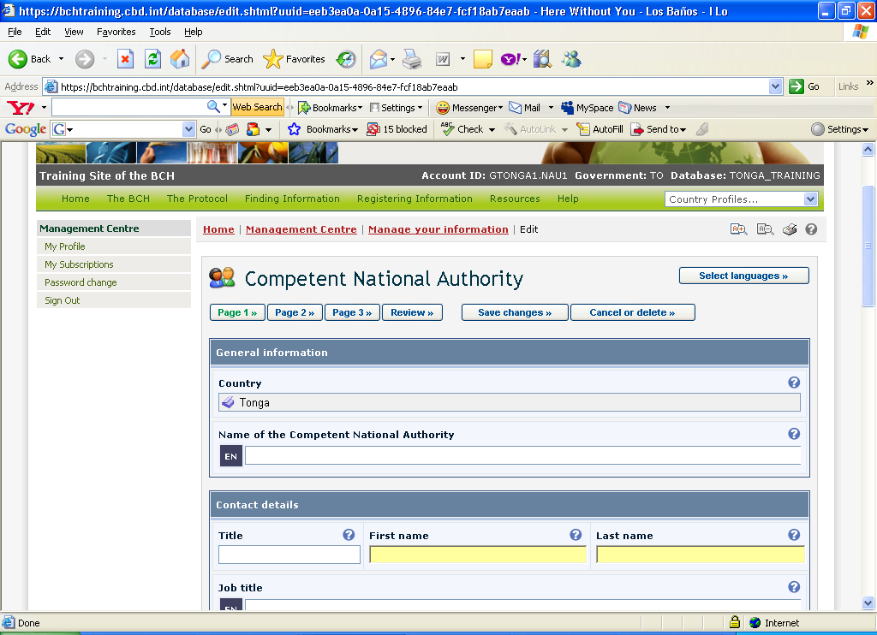
Figure 4. The “Select Language” Button, BCH Management Centre

A drop-down list of additional languages is available and selected language can be saved (Figure 5). After which, the authorized users can register information on the BCH portal in both the UN language of choice and another one (Figure 6)
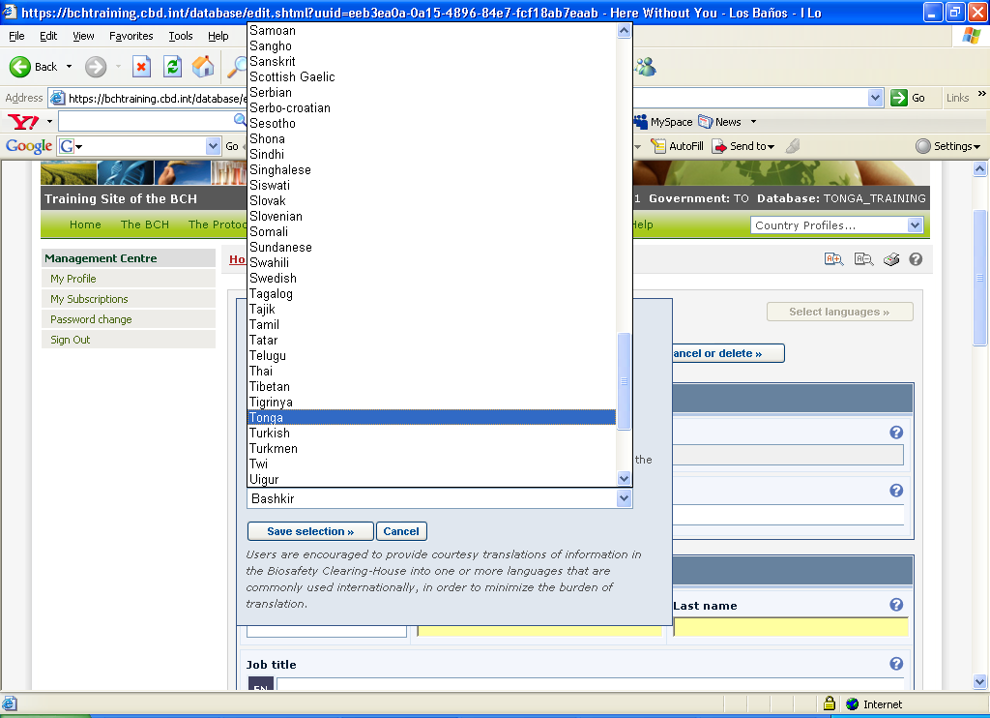
Figure 5. “Additional Languages” drop down list from BCH Management Centre.

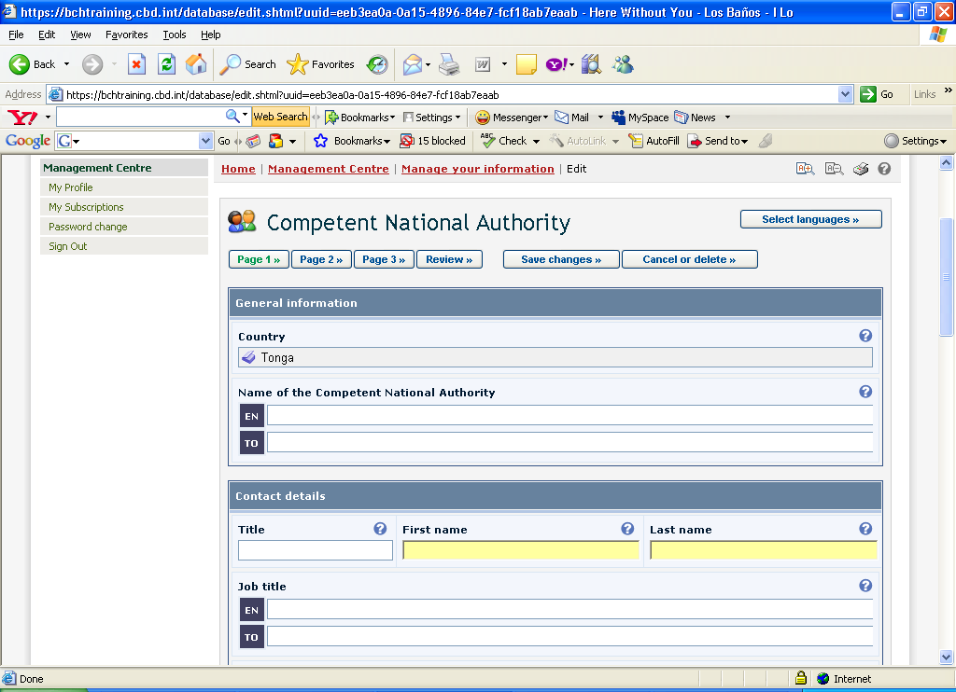
Figure 6. Registering Information with Official UN Language and another Additional Language Centre.

The complete list of language code, however can be found at:
http://www.loc.gov/standards/iso639-2/php/English_list.php

Section 2. Embedding the JavaScript and AJAX Plug-In

2.1 Embedding the JavaScript
What you will learn in this section:

- The JavaScript and AJAX Plugin formats.
- Where to place the JavaScript and AJAX Plugins

JavaScript is important to make the AJAX Plug-In work. The webpage (regardless of format – html, php, asp, etc.) where your front-end is (where information will be displayed) should contain the following lines:
<script type="text/javascript" charset="utf-8" src="http://bch.biodiv.org/centralportal/ui/offsite/bch-offsite.js">
</script>

Figure 7. Sample JavaScript.
Now where do we put the JavaScript?

Generally, JavaScript can be placed within the head or body section or can be declared as an external script. If you want the script to be executed when it is called or when a user triggers an event, put the script in the head section.
<html>
<head>
<script type="text/javascript" charset="utf-8" src="http://bch.biodiv.org/centralportal/ui/offsite/bch-offsite.js">
</script>
</head>

Figure 8. Embedding the JavaScript within the head tags.
For JavaScript that needs to be executed immediately while the page loads into the browser, put it in the body section.
<html>
<head>
</head>
<body>
<script type="text/javascript" charset="utf-8" src="http://bch.biodiv.org/centralportal/ui/offsite/bch-offsite.js">
</script>
</body>

Figure 9. Embedding the JavaScript within the body section.
The external script is recommended if you want to run the same JavaScript on several pages without having to write the same script on every page. The JavaScript is written in an external file and saved with a .js file extension.
To use the external script, point to the .js file in the "src" attribute of the <script> tag:
<html>
<head>
<script src="external.js"></script>
</head>
<body>
</body>
</html>

Figure 10. JavaScript written in an external file.

2.2 Integrating the AJAX Plug-In
After declaring the JavaScript, we are now ready to integrate the following AJAX Plug-In:

<script type="text/javascript" charset="utf-8" >
GenerateRecords("documentType", "countryCode", "language");
</script>

Figure 11. AJAX Plug-In to be integrated.
where documentType is the value of the type of information to be displayed (Table 2), countryCode is the 2-letter ISO 3166 country codes; and language is the code which specifies which language the information should be displayed.
To illustrate, let us consider the different available documents in India. First, we generate the country profile of India.
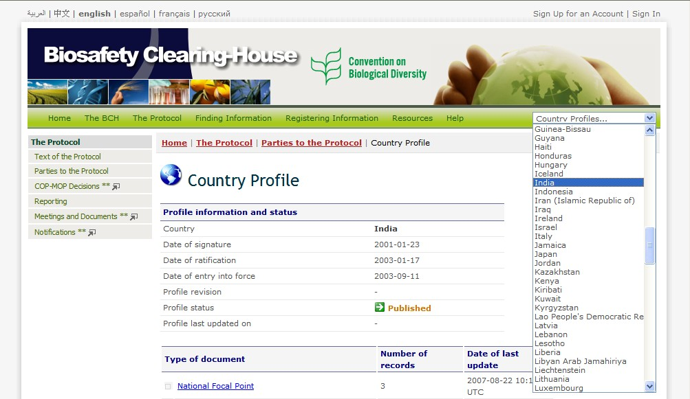
Figure 12. Country profile of India generated from the BCH Portal.
Then, we check for available information on India. Based from the generated page, the types of document available information on India are the following:
- National Focal Point,
- Competent National Authority,
- National Biosafety Website or Database,
- Law, Regulation or Guidelines,
- Capacity Building Projects, and
- Country Needs Priority.
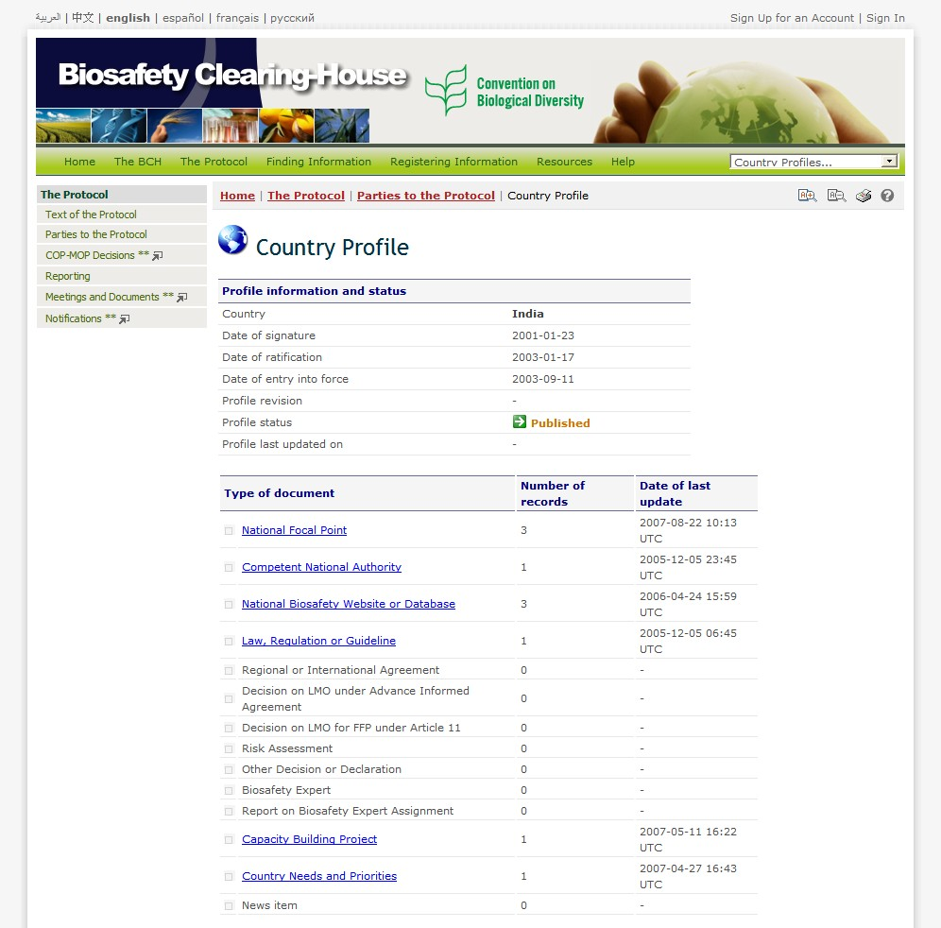
Figure 13. Types of document available in India.

To display the abovementioned information on the National BCH Webpage of India, the following AJAX Plug-Ins will be used:

- For the National Focal Point

<script type="text/javascript" charset="utf-8" >
GenerateRecords("focalPoint ", "IN”, "en");
</script>

- Competent National Authority

<script type="text/javascript" charset="utf-8" >
GenerateRecords("authority", "IN”, "en");
</script>

- National Biosafety Website or Database

<script type="text/javascript" charset="utf-8" >
GenerateRecords("nationalDatabase", "IN”, "en");
</script>

- Law, Regulation or Guidelines

<script type="text/javascript" charset="utf-8" >
GenerateRecords("law", "IN”, "en");
</script>

- Capacity Building Projects

<script type="text/javascript" charset="utf-8" >
GenerateRecords("capacityBuildingProject", "IN”, "en");
</script>

- Country Needs Priority

<script type="text/javascript" charset="utf-8" >
GenerateRecords("countryNeedsAndPriorities", "IN”, "en");
</script>

Section 3. Application of AJAX Plug-In to the National BCH Webpage

Note: Notepad will be used to edit/modify the webpages for all the examples given in this section.

3.1 Displaying Information on National Focal Point(s)

For this example, we will be using the Bahamas Biosafety Clearing-House webpage to display information on Focal Point(s). HTML was used for its web development tool. The filename for sample file for this example is the focalpoint.htm.

Opening the Bahamas Biosafety Clearing-House Webpage on Focal Point(s), focalpoint.htm
Step 1. Open the Notepad program.
  - From the desktop, go to start button and click it.
  - Move cursor to All Programs, a submenu will appear.
  - From the submenu, move mouse to accessories, sub-submenu will appear.
  - From the sub-submenu, select Notepad and click it.
  - The Notepad program will open in another window.

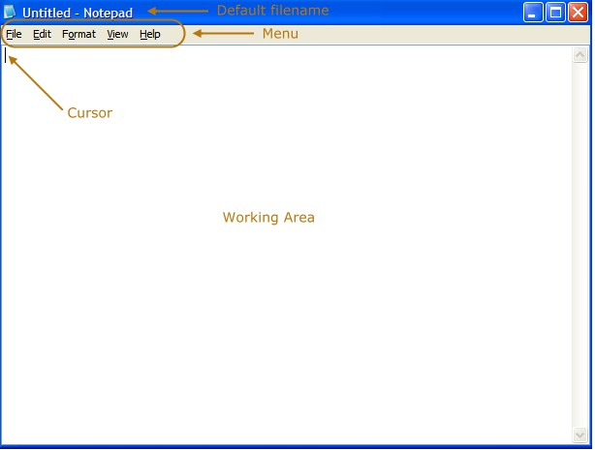
Figure 14. Parts of a Notepad.

Step 2. Open the file, focalpoint.htm.
  - From Notepad, move mouse to the menu.
  - Select the File option from the menu, click it.
  - Select the open option. A new window opens prompting the user to locate the file to be opened.
  - Go the folder containing the file, focalpoint.htm. In this example, the file is located at the c drive, folder AJAX, subfolder Bahamas.
  - Click to open the file. The source code for the focalpoint.htm file will be displayed.
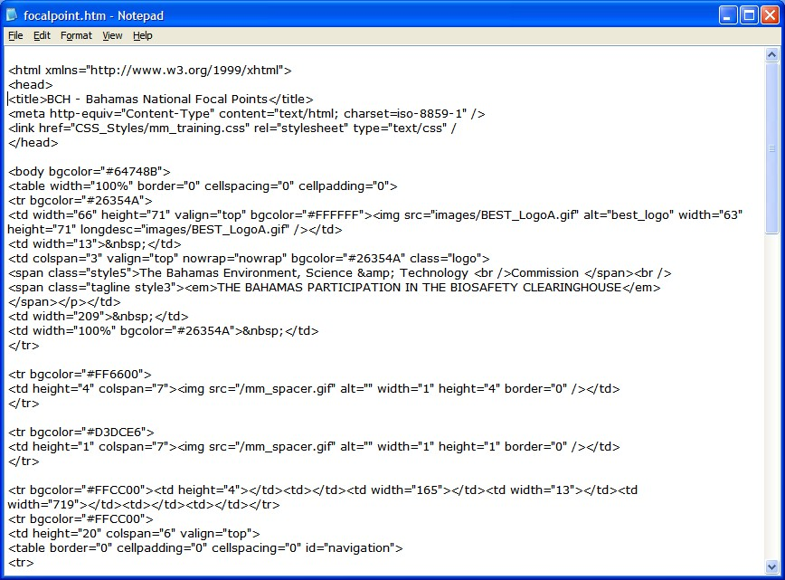
Figure 15. Source code of focalpoint.htm file.

Inserting the JavaScript and AJAX Plug-in

Step 1. Insert the JavaScript.
  - With the focalpoint.htm file open, move the cursor to the head section of the webpage.

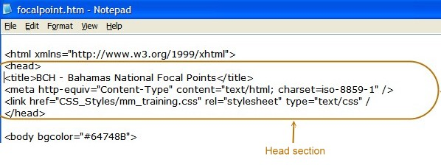

Figure 16. Head section of the focalpoint.htm file.

  - Move cursor to the end of the
<link href="CSS_Styles/ mm_training.css" rel="stylesheet"
type="text/css" />
line. Press the enter key to insert a line.
  - Type the following,
<script type="text/javascript" charset="utf-8" src="http://bch.biodiv.org/centralportal/ui/offsite/bch-offsite.js"></script>

  - From the menu, select File, then save to save the modifications made to focalpoint.htm file. The resulting page will look like the following:

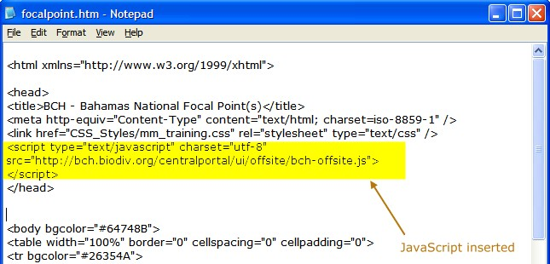
Figure 17. Edited focalpoint.htm with the JavaScript inserted.

Step 2. Insert the AJAX Plug-In.

  - With the focalpoint.htm file open, move the cursor to the body section of the webpage.
  - We want the information to be displayed after the introduction of the Bahamas Focal Point(s). Hence, we will move our cursor down within the body section and locate for the text containing the said introduction.

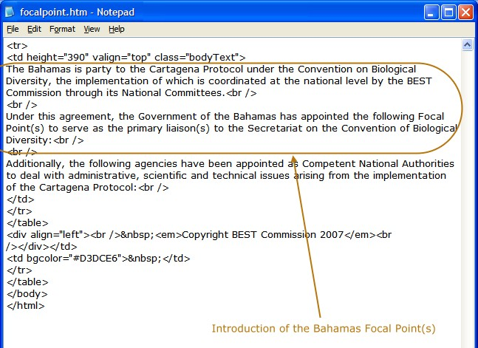
Figure 18. Text containing the introduction to the Bahamas Focal Point(s).

  - After the break code <br />, press enter and type the following AJAX Plug-In,

<script type="text/javascript" charset="utf-8" >
GenerateRecords("focalPoint", "bs", "en");
</script>

Note: The value of the parameters for the GenerateRecords function are ‘focalPoint’ for the information we want to display; ‘bs’, the ISO 3166 code for Bahamas; and ‘en’ meaning the information will be displayed in English language.

2.4 From the menu, select File, then save to save the modifications made to focalpoint.htm file. The resulting page will look like the following:

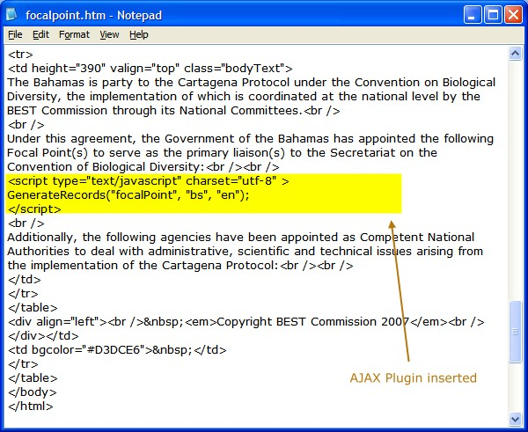

Figure 19. AJAX Plug-In inserted.

Displaying the webpage using the browser

After embedding the AJAX Plug-In in the focalpoint.htm file, the information on the Bahamas focal point(s) is/are now ready to be displayed/generated at the Bahamas webpage. This will be processed from the BCH Central Portal. To display the info,

Step 1. Open your browser, Internet Explorer or Mozilla Firefox.
Step 2. Type the url, http://www.bahamas.bch.cbd.int/focal.htm.

Information generated by the use of AJAX Plug-In

The following images will demonstrate how the information will be displayed at the front-end:

- Without the AJAX Plug-In

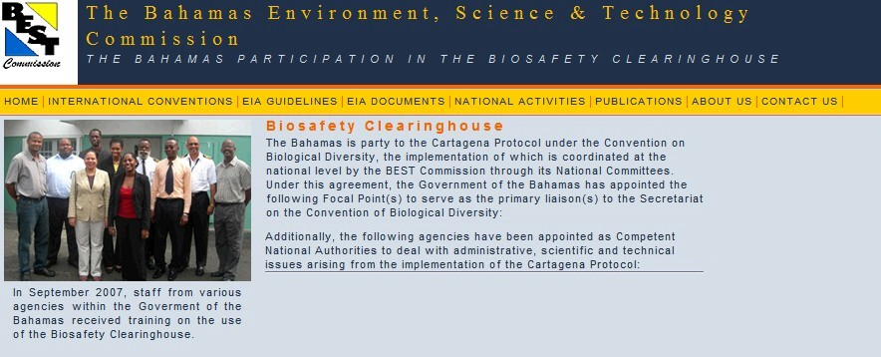
Figure 20. The Bahamas BCH webpage on Focal Point with no AJAX Plug-In inserted.
b. With AJAX Plug-In

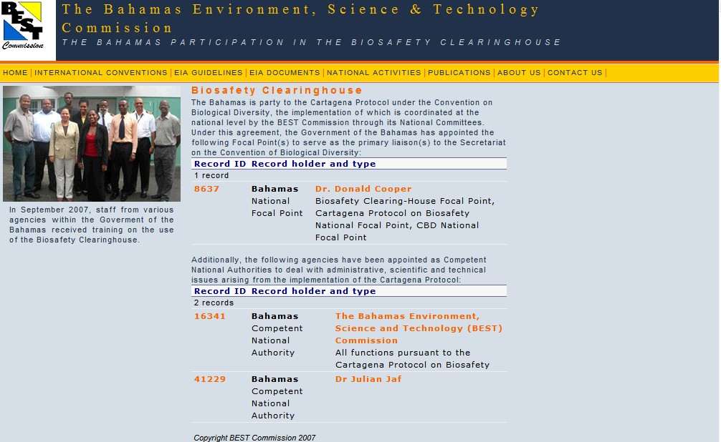

Figure 21. The Bahamas BCH webpage on Focal Points with AJAX Plug inserted.

3.2 Some More Examples Using Other Web Development Tools

3.2.1 Using PHP Hypertext Preprocessor (PHP)

The Egyptian Biosafety Clearing- House webpage uses php as its web development tool. This will be used to generate information on Laws and Regulations. Filename for the sample file that will be used for this example is regulations.php.

3.2.1.1 Opening the Egyptian Biosafety Clearing-House Webpage, regulations.php

Step 1. Open the Notepad program.

  - From the desktop, go to start button and click it.
  - Move cursor to All Programs, a submenu will appear.
  - From the submenu, move mouse to accessories, sub-submenu will appear.
  - From the sub-submenu, select Notepad and click it.
  - The Notepad program will open in another window.

Step 2. Open the file, regulations.php.

  - From Notepad, move mouse to the menu.
  - Select the File option from the menu, click it.
  - Select the open option. A new window opens prompting the user to locate the file to be opened.
  - Go the folder containing the file, regulations.php. In this example, the file is located at the c drive, folder AJAX, subfolder Egypt.
  - Click to open the file. The source code for the regulations.php file will be displayed.

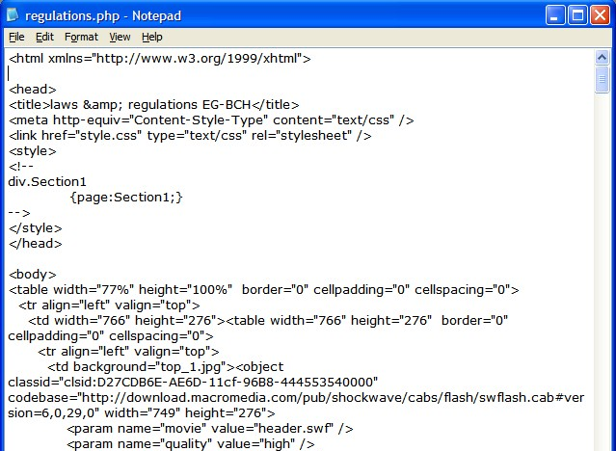
Figure 22. Source code of regulations.php file.

3.2.1.2 Inserting the JavaScript and AJAX Plug-In

Step 1. Insert the JavaScript.
  - With the regulations.php file open, move the cursor to the head section of the webpage.

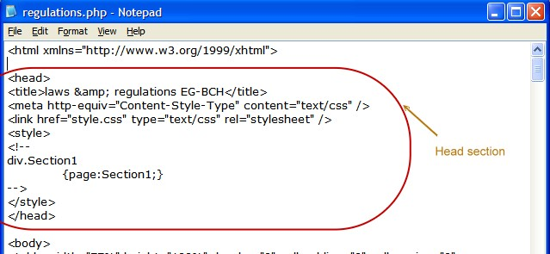
Figure 23. Head section of the regulations.php file.

  - Move cursor to the end of the
<link href="CSS_Styles/ mm_training.css" rel="stylesheet" type="text/css" />
line. Press the enter key to insert a line.
1.3 Type the following,
<script type="text/javascript" charset="utf-8" src="http://bch.biodiv.org/centralportal/ui/offsite/bch-ffsite.js"></script>

1.4 From the menu, select File, then save to save the modifications made to regulations.php file. The resulting page will look like the following:
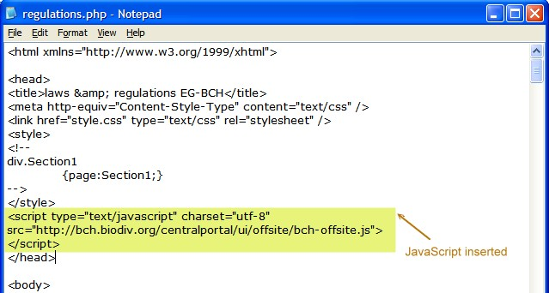
Figure 24. Edited regulations.php with the JavaScript inserted.
Step 2. Insert the AJAX Plug-In.

  - With the regulations.php file open, move the cursor to the body section of the webpage.
  - We want the information to be displayed after the sentence Laws and protocols dealing with Biosafety in Egypt. Hence, we will move our cursor down within the body section and locate for the text containing the said statement.

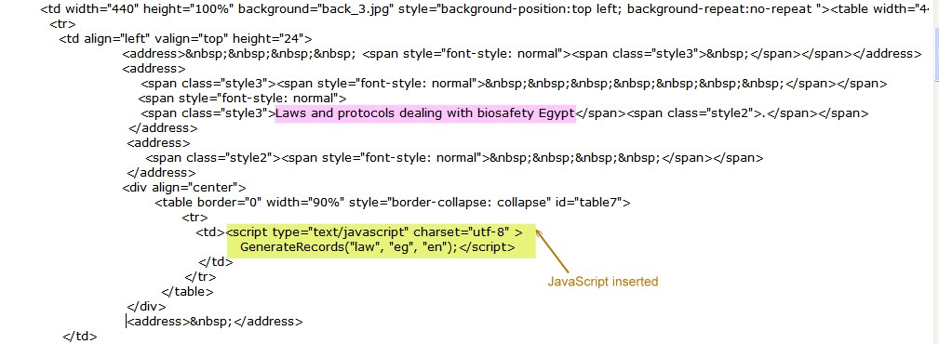
Figure 25. Text containing the introduction to the Egyptian Laws and protocols

  - Type the following AJAX Plug-In within the table row tag , <td> </td>:

<script type="text/javascript" charset="utf-8" >
GenerateRecords("law", "eg", "en");
</script>

Note: The value of the parameters for the GenerateRecords function are ‘law’ for the information we want to display; ‘eg’, the ISO 3166 code for Egypt; and ‘en’ meaning the information will be displayed in English language.

  - From the menu, select File, then save to save the modifications made to regulations.php file. The resulting page will look like the following:

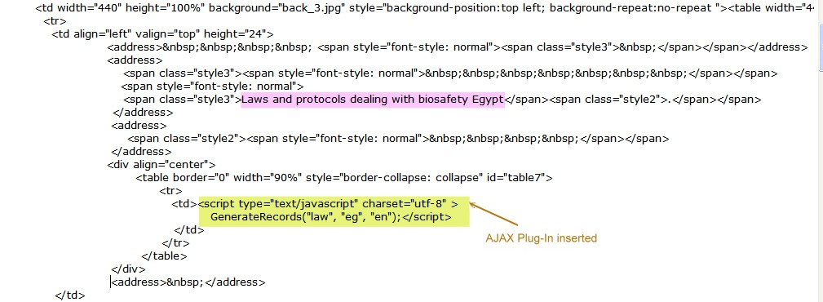

Figure 26. AJAX Plug-In inserted.

3.2.1.3 Displaying the webpage using the browser

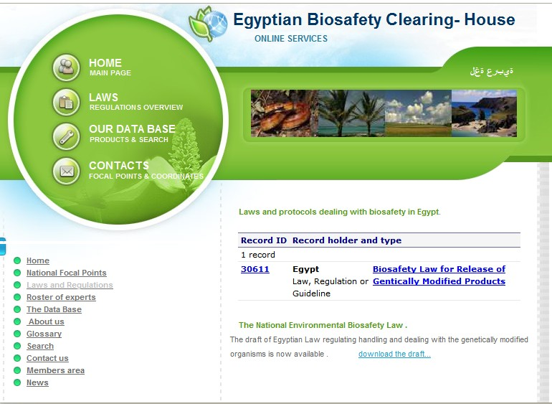

Figure 27. List of Laws and protocols dealing with Egyptian Biosafety Clearing-House.

3.2.2 Using Active Server Pages (ASP)

The Nigerian Biosafety Clearing- House webpage, makes use of the asp technology for its web development. The web page on experts, http://biosafety-nigeria.org/experts.aspx, will be used to generate information on available experts on the Nigerian Biosafety Clearing-House.

3.2.2.1 Opening the Egyptian Biosafety Clearing-House Webpage, experts.aspx

Step 1. Open the Notepad program.

  - From the desktop, go to start button and click it.
  - Move cursor to All Programs, a submenu will appear.
  - From the submenu, move mouse to accessories, sub-submenu will appear.
  - From the sub-submenu, select Notepad and click it.
  - The Notepad program will open in another window.

Step 2. Open the file, experts.aspx.

  - From Notepad, move mouse to the menu.
  - Select the File option from the menu, click it.
  - Select the open option. A new window opens prompting the user to locate the file to be opened.
  - Go the folder containing the file, experts.aspx. In this example, the file is located at the c drive, folder AJAX, subfolder Nigeria.
  - Click to open the file. The source code for the experts.aspx file will be displayed.
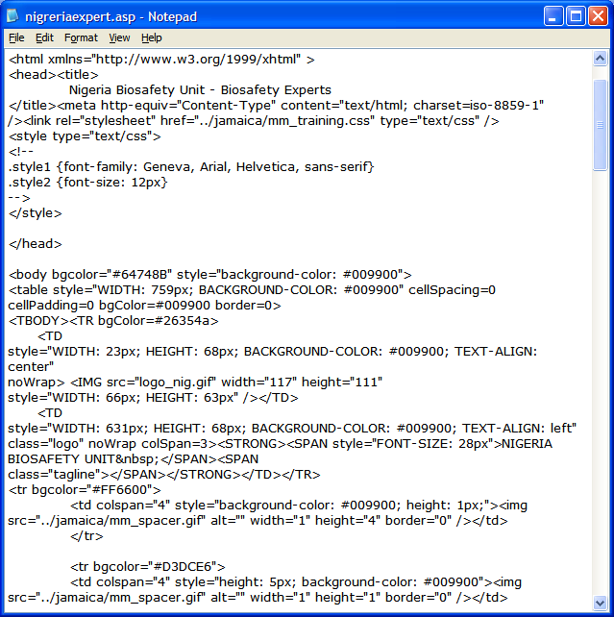

Figure 28. Source code of experts.asp file.

3.2.2.2 Inserting the JavaScript and AJAX Plug-In

Step 1. Insert the JavaScript.

  - With the experts.aspx file open, move the cursor to the head section of the webpage.

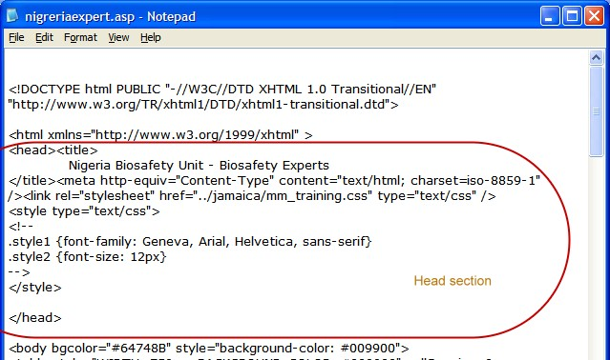
Figure 29. Head section of the experts.asp file.

  - Move cursor to the end of the
<link href="CSS_Styles/ mm_training.css" rel="stylesheet" type="text/css" />
line. Press the enter key to insert a line.
1.3 Type the following,
<script type="text/javascript" charset="utf-8" src="http://bch.biodiv.org/centralportal/ui/offsite/bch-ffsite.js"></script>
1.4 From the menu, select File, then save to save the modifications made to experts.aspx file. The resulting page will look like the following:

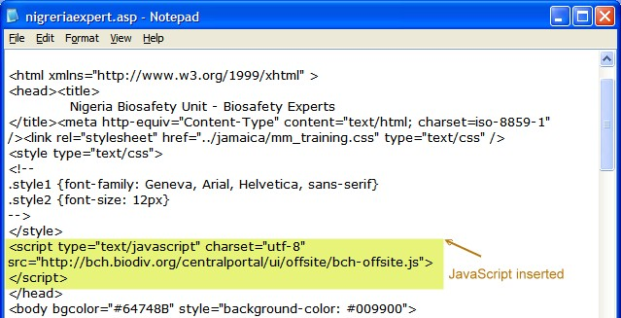

Figure 30. Edited experts.asp with the JavaScript inserted.
Step 2. Insert the AJAX Plug-In.

  - With the experts.aspx. file open, move the cursor to the body section of the webpage.
  - We want the information to be displayed after the introduction of the Nigerian Roster of Experts on Biosafety. Hence, we will move our cursor down within the body section and locate for the text containing the said introduction.

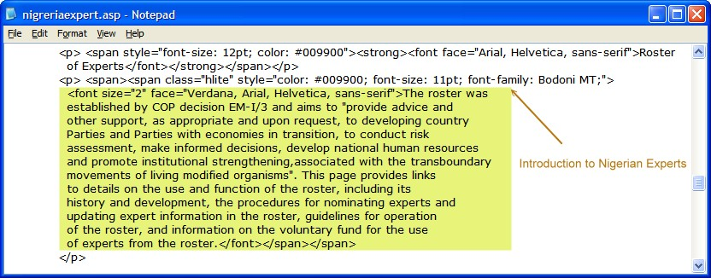
Figure 31. Text containing the introduction to the Nigerian experts.
  - After the break code <br />, press enter and type the following AJAX Plug-In,

<script type="text/javascript" charset="utf-8" >
GenerateRecords("biosafetyExpert ", "ng", "en"); </script>

Note: The value of the parameters for the GenerateRecords function are ‘biosafetyExpert’ for the information we want to display; ‘ng’, the ISO 3166 code for Nigeria; and ‘en’ meaning the information be displayed in English language.

2.4 From the menu, select File, then save to save the modifications made to experts.aspx file. The resulting page will look like the following:

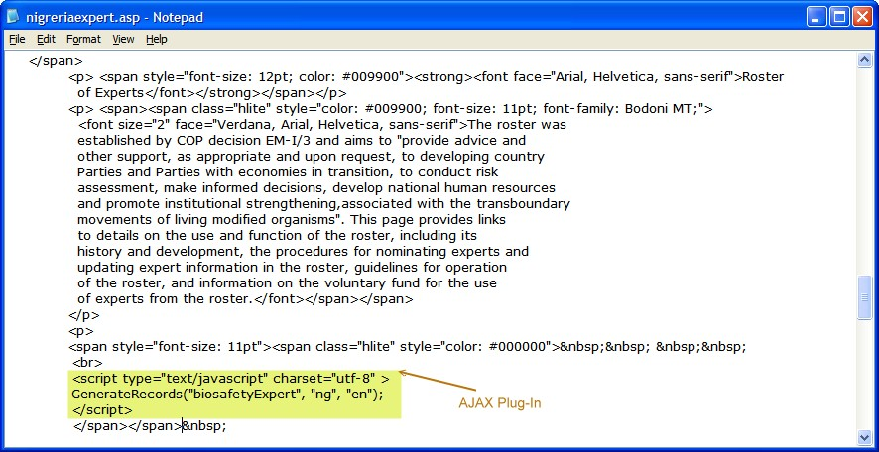
Figure 32. AJAX Plug-In inserted.

3.2.2.3 Displaying the webpage using the browser


Figure 33. Roster of Nigerian Experts on Biosafety Clearing-House.

Remarks: Noticed that for all the three examples, the same steps were followed to display the desired information (Focal Points, Laws and Regulations, and Experts) regardless of the web development tools used. Only the value of the parameters for the Generate Records function are to be altered.
Acknowledgement

The developers of this manual would like to acknowledge Mr. Philippe Leblond of SCBD, Mr. Manuel Poppe, Brazil NBCH developer, the BCH Regional Advisors and country BCH developers who provided their comments, technical inputs and necessary support which were all instrumental in this endeavor. Special thanks also is given to Ms. Cecille B. Leano, a web development specialist from the Philippines who also formed part of the technical support team for this project.

